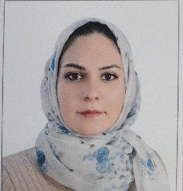

SAMA FOUAD MAJEED

Academic achievement: M.S.C degree in Communication, Malaysia , UniversitiPutra malaysia(UPM) – graduated in 2018.
Academic title: Assistant teacher.

